1.Mkdir



Create a new directory

2.cd



Cd means change directory

3.vi space

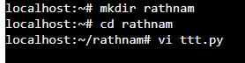

4:Import os



5,:wq!

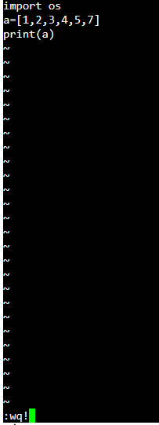

Floder in save

6:Out put



7:Ls



Current working file

8:cp



Or

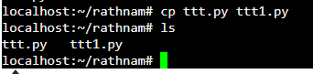

9:rmdir

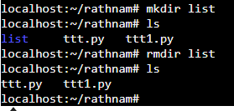

Remove directory rathnam “ttt.py ttt1.py” remove this 2 floders

10:dir

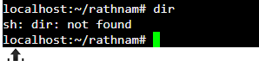  
 dir means directory not found

11:Clear



All files clear only rathnam

12:cd



13.whoami



Display the user name currently logged in terminal

14.less

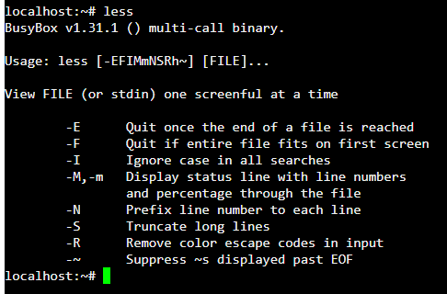

Less means compress data

15.echo



Display output immediate ,instantly

16,tuch



To create empty file

17.pwd

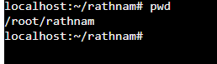

Current working file

18.head(file name)

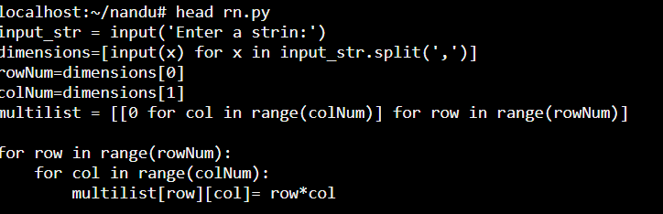

Print the frist n numbers of data given the out put

19.tail(file name)

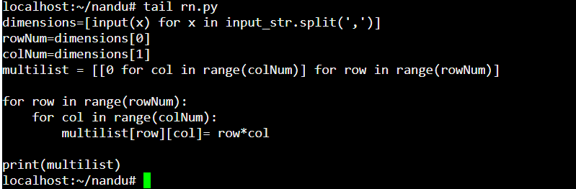

Print the last 10 lines

20.gzip

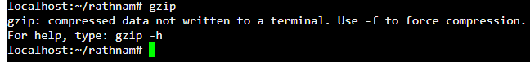

Compress the data

21.gunzip

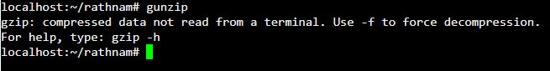

Converts zip file into original file

22.install



Used to copy file and set attrinutes

23.password



Create a new password

24.read



25.mkdir –p

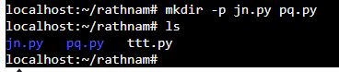

Mkdir means create multiple floders

26.sleep



Used to create a dummy job

27.cat

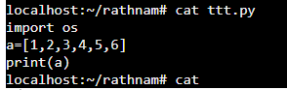

Display the contents of file

28.mv

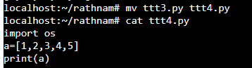

Mv means one floder to another floder

29.touch



Create a empty file

30.ps

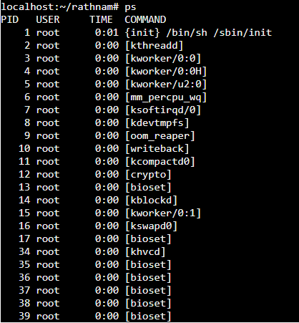

Ps Display information about running processes

31.sudo(superuser do)



Install like python ,django install applications

32.Find

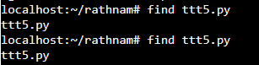

Search for files and directories within a specified location

33.man



Display the manual pages for commands

34.ssh



**ssh (Secure Shell):** Connect to a remote server securely.

35.wget



Download file from the internet

36.tar(tape archive):

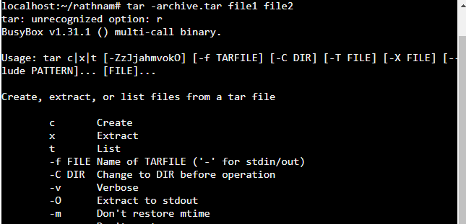

Create or extract compressed archive files.

36.Chmod

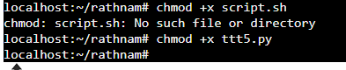

Change file permissions.

37.chown



Change file or directory ownership

38.date



Display time and date

39 top/htop

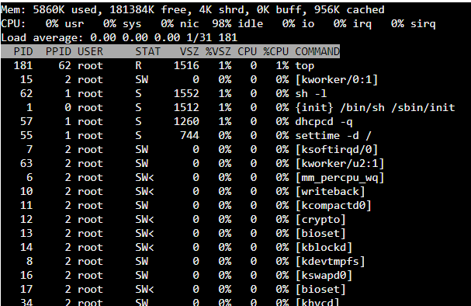

Monitor system processes and resource usage

40.Shutdown/reboot



Or



41.history

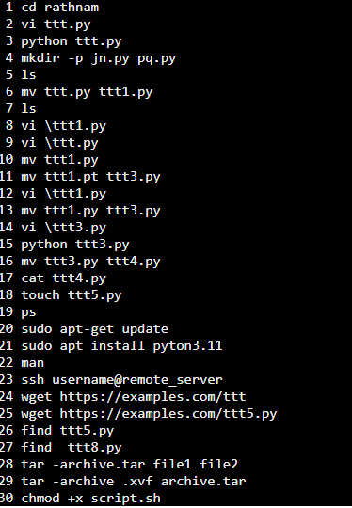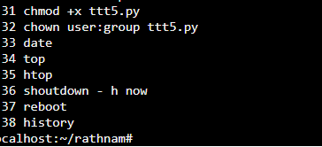

42.df/du

Df –h

Du –sh

